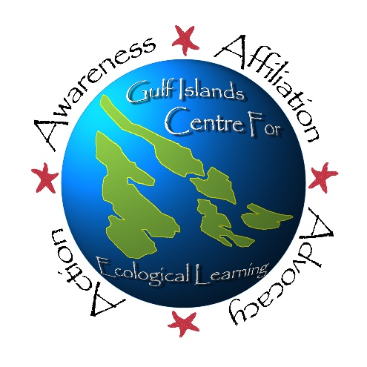
Participant’s Name:
Saturna Island | Aug. 6-10 2018
SUMMER EARTH EDUCATION PROGRAM
REGISTRATION FORM

Age: Gender: Birthdate:

Name of Participant’s Parents/Guardians:

Island Phone Number: Cell Phone:

Other Phone Number (if applicable):

Island Emergency Contact Name & Phone # (not a Parent or Guardian):

Participant’s Home Phone Number (if different from above):

Participant’s Home Address:

Parent/Guardian E-Mail:

Does your child have any allergies or medical conditions we need to be aware of? If so, please describe any procedures we need to know about in an emergency. (use back of page if necessary):

PARTICIPANT’S Medical Number:

Please enclose fees in full. Amount enclosed:
Registration for one week is $210 (includes GICEL t-shirt).
Mail to:
Gulf Islands Centre for Ecological Learning
171 Georgina Pt. Road
Mayne Island, BC
V0N 2J1
Each additional child is $160 (includes GICEL t-shirt) for the first week & $150 for any additional weeks.
Subsidies are available for families who need assistance.

T-shirt size:

Which program are you registering for? (Island and dates needed):

