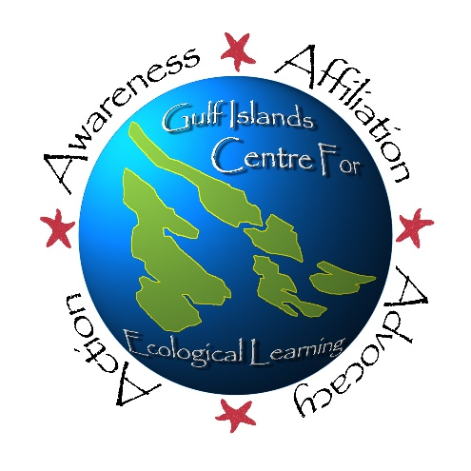
Participant’s Name:
Environmental Leaders Apprenticeship Program
Linnaea Farm, Cortes Island | Aug. 14-21 2018
REGISTRATION FORM

Age: Gender: Birthdate:

Name of Participant’s Parents/Guardians:

Island Phone Number: Cell Phone:

Other Phone Number (if applicable):

Emergency Contact Name & Phone # (not a Parent or Guardian):
Participant’s Home Phone Number (if different from above):

Participant’s Home Address:

Parent/Guardian E-Mail:

Does your child have any allergies or medical conditions we need to be aware of? If so, please describe any procedures we need to know about in an emergency. (use back of page if necessary):

PARTICIPANT’S Medical Number:

Please enclose fees in full. Amount enclosed:
Mail to:
Gulf Islands Centre for Ecological Learning
171 Georgina Pt. Road
Mayne Island, BC
V0N 2J1
$510 for participants traveling up with us from the Southern Gulf
Islands / Victoria / Vancouver. $360 for participants joining us on
Cortes Island. Registration includes a t-shirt. Subsidies are available for families who need assistance. Please contact us to inquire. T-shirt size:

